**Patton troubleshooting [As a modem only]:**  
-To check DSL status and system uptime  
  
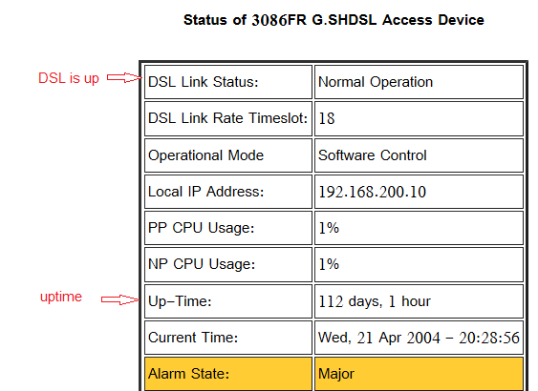  
  
  
  
-To check DSL alarms [system configuration---Alarm]  
  
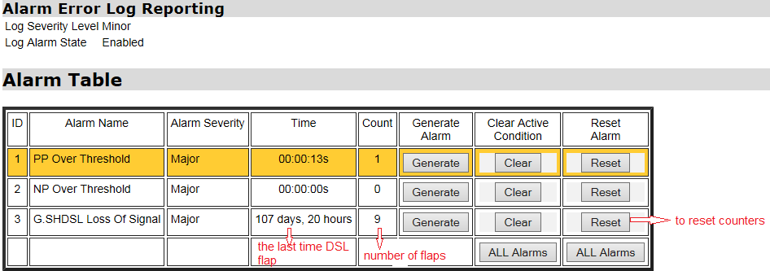

To check SNR margin and errors [SHDSL-status] -

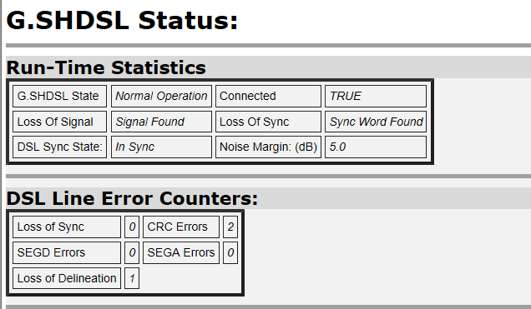  
  
 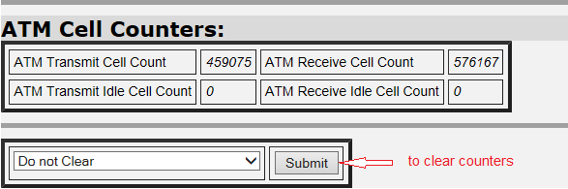

To change clocking and DSL speed [SHDSL configuration]

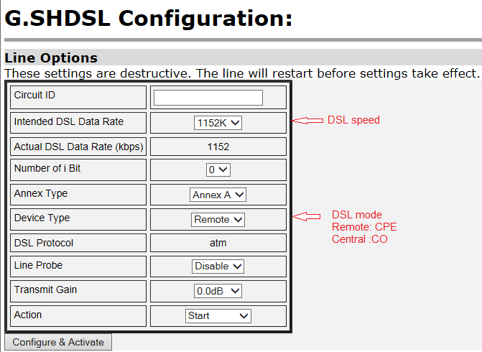

-to check that LMI is physically up [serial- status]  
  
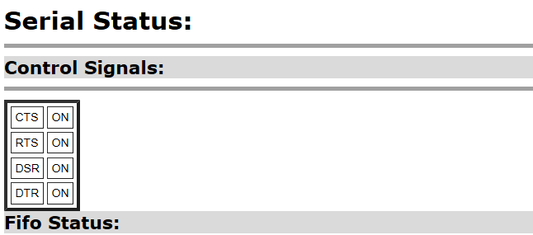

-To check serial speed [serial- configuration]

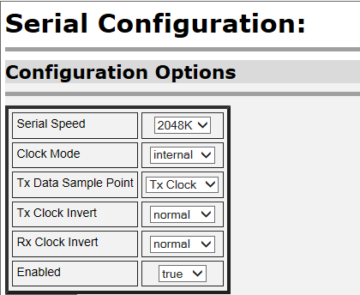

-To check the LMI type and status [service configuration –LMI management]

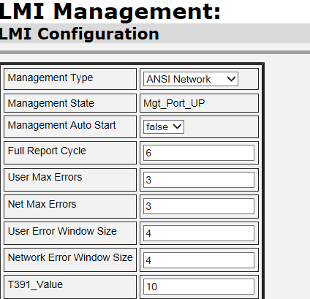  
  
 -to check the send and receive frames [IWF-FRS setup – Group A]

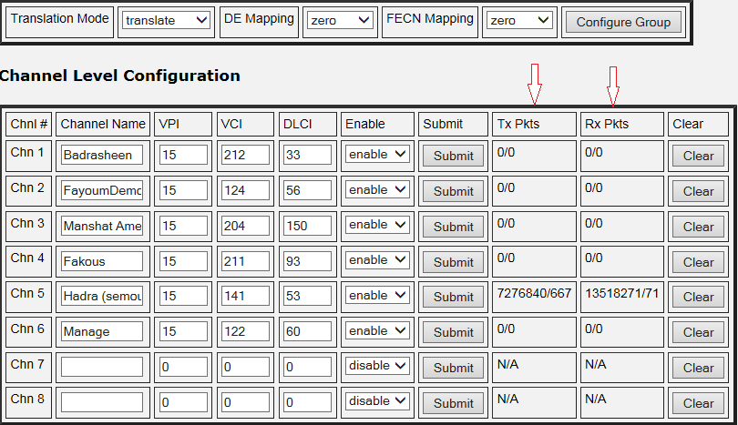  
  
to modify authentication parameters [system configuration- authentication –edit user] -

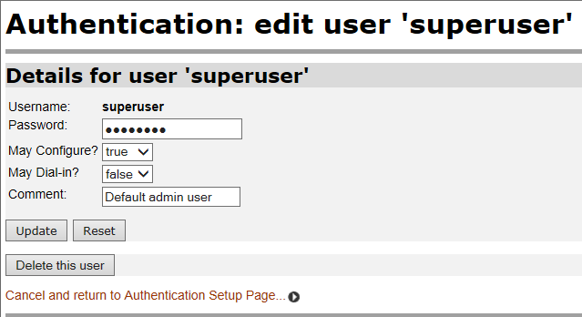

-to upgrade firmware [system configuration -update]

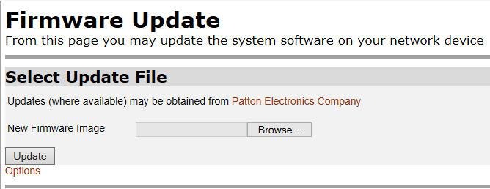

to save configuration after any modification [system configuration-save]-

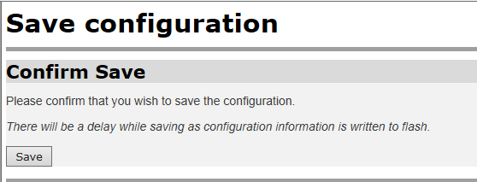

to backup or restore configuration [system configuration- backup/restore] -

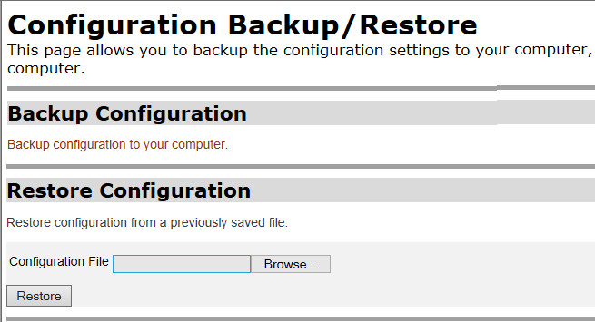

-to restart or reset the modem to its factory setting [system configuration-restart]

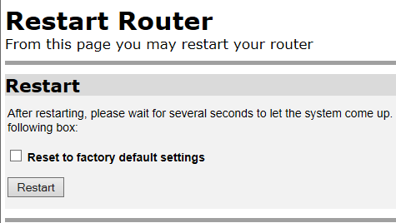

**Patton troubleshooting [As a modem /router]:**  
to check Ethernet status [system status ]-

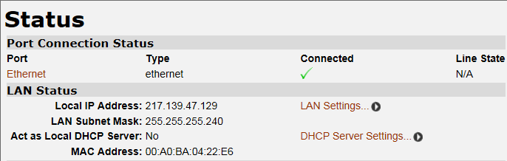

-to check how many times the Ethernet connection has flapped [Ethernet-view advanced attributes]  
  
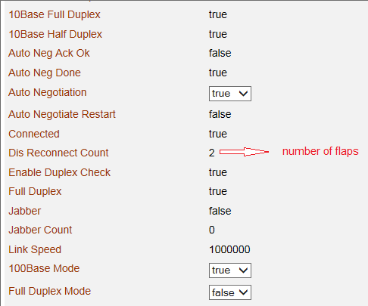

to check routes [service configuration- IP routes ]  
  
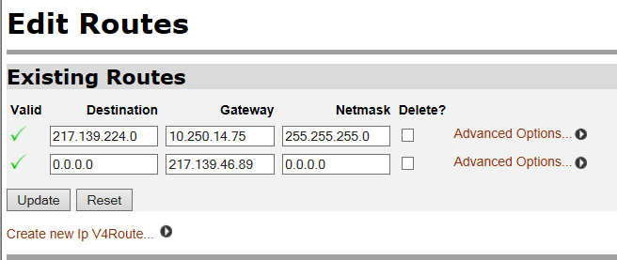

to enable and configure DHCP [service configuration –DHCP server-create new subnet]  
  
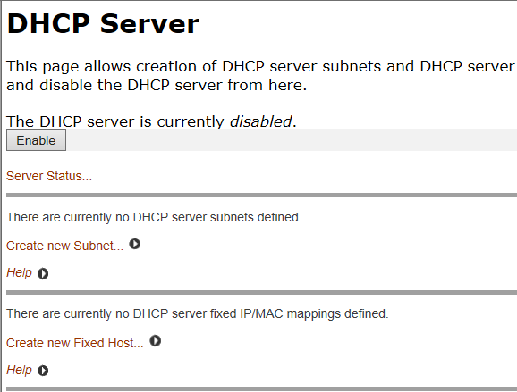  
  
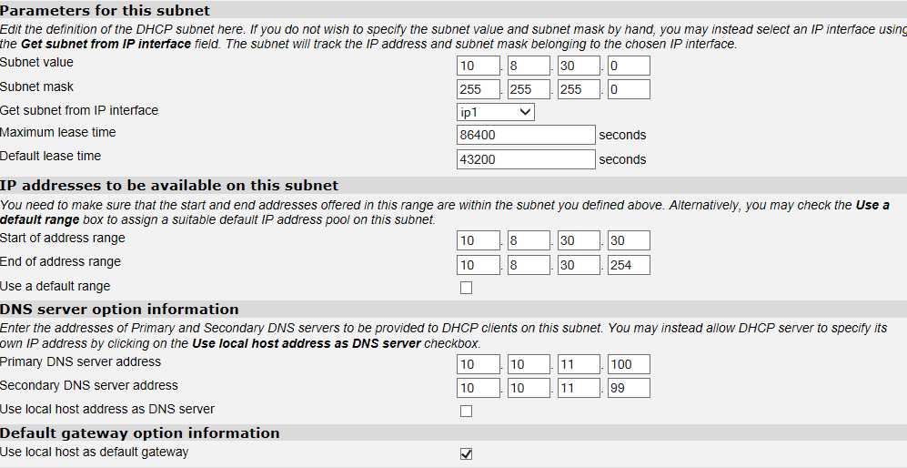

-to use test tools [system configuration tools]   
  
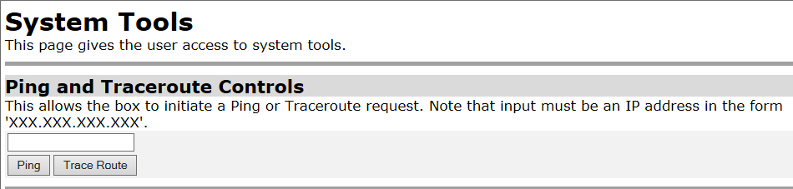

PartII- troubleshooting using command lines  
  
-to get the system uptime:  
   
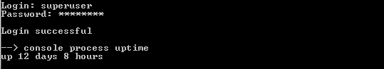

to check DSL status and SNR margin :  
  
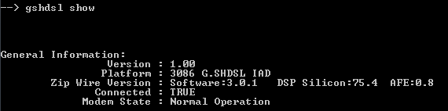

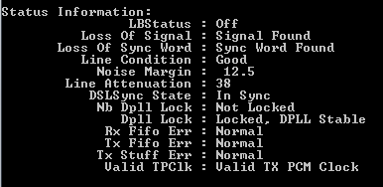  
  
-To check DSL alarms  
  
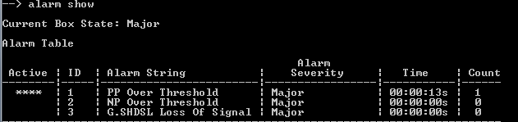

-To check serial speed [serial- configuration]

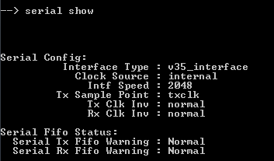  
  
-To check the LMI type and status [service configuration –LMI management]  
  
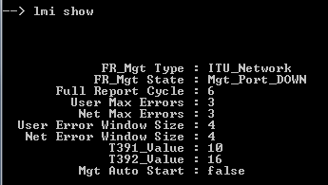  
  
 -to check the send and receive frames [IWF-FRS setup – Group A]  
  
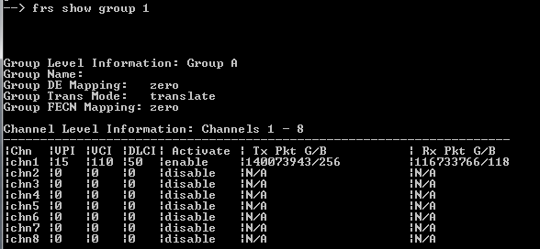

-to restart, reset the modem to its factory setting, restore, backup and save configuration

  
  
  
  
-to show firmware version:  
  
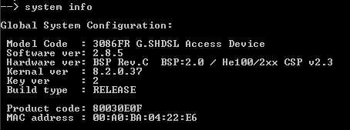  
  
to check Ethernet status [system status ]-

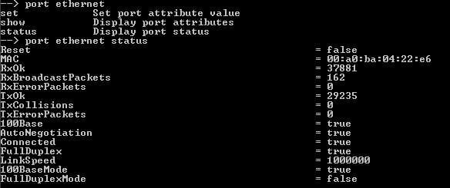  
  
-to check how many times the Ethernet connection has flapped [Ethernet-view advanced attributes]  
  
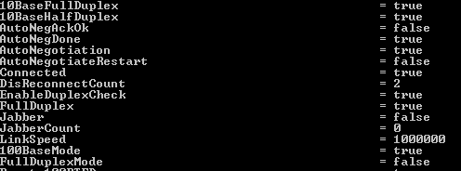

-to check ARP table and clear entries:  
  
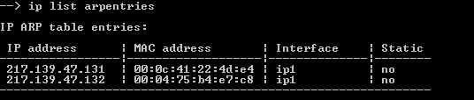  
  
  
  
  
-to use test tools [system configuration tools]  
  
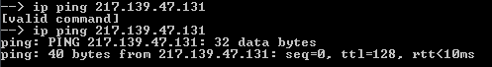  
  
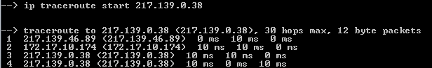  
  
  
  
to check routes [service configuration- IP routes ]  
  
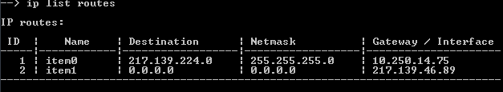  
  
  
  
to list IP address of interface:  
  
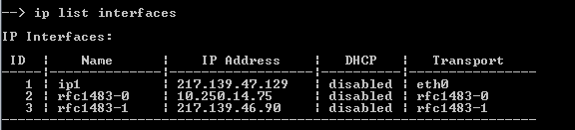

-to list current connections:  
  
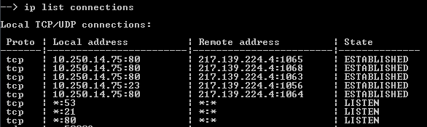

-to add static route:  
  
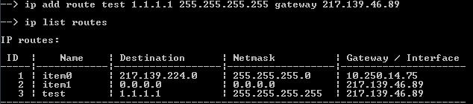

To delete route:  
  
